**FPT ACADEMY INTERNATIONAL**

**FPT – APTECH COMPUTER EDUCATION**

**Centre Name: ACE-HCMC-2-FPT.**

**Address: 590 Cach Mang Thang 8, District 3, Ho Chi Minh City, Viet Nam.**

**Clothes Shop**

|  |  |  |
| --- | --- | --- |
| **Supervisor:** | **Mr. NGO PHUOC NGUYEN** | |
| **Semester:** | **4** | |
| **Batch No:** | **T1.2011.E1** | |
| **Group No:** | **6** | |
| **Order:** | **Full name** | **Roll No.** |
| **1.** | **Tran Thanh Thien** | **Student1130994** |

**REVIEW 2**

1. **Use Case and Sequence Diagram**
2. **Use Case**
3. 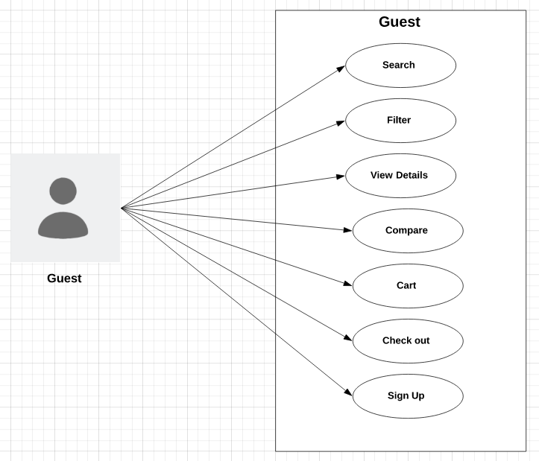**Guest**
4. **Member**

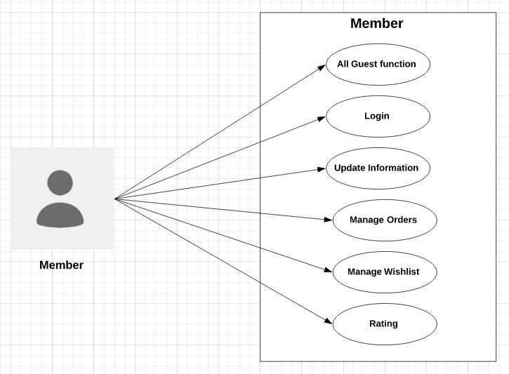

1. **Admin**

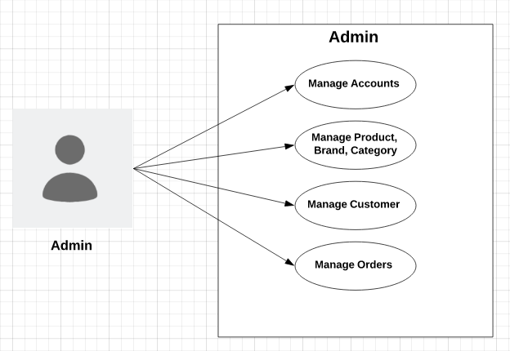

1. **Sequence Diagram**
   1. **Guest**

**a) Search - Button**

|  |  |  |
| --- | --- | --- |
| **Author** |  | |
| **Use Case Name** | Search – Search button | |
| **Actors** | Guests and Members | |
| **Description** | When search button is clicked, search result page will be displayed with result list of products and their information | |
| **Requirements** | Search string can not be blank. | |
|  | **Actor Actions** | **System Responses** |
| **Basic flow** | 1. Actor input search string and click on search button. | 2. System check the search string [Exception 1] 3. System create an empty list to contain search result. 4. Search in Products table to find products which have names contain the search string (ignore case) and add them to result list. 4. Display the result list in the search result page. |
| **Exception** | 1. Actor left the search string empty | 1. An error message will be display: “Search string can not be empty” |

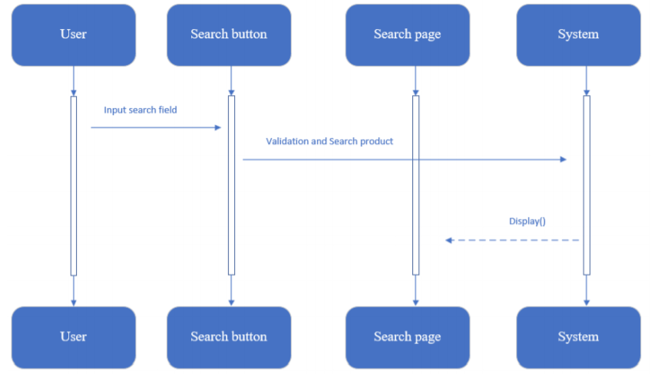

1. **Filter**

|  |  |  |
| --- | --- | --- |
| **Author** |  | |
| **Use Case Name** | Filter | |
| **Actors** | Guests and Members | |
| **Description** | Allows customers view all products which are in the same categories, brands. Products will be displayed with the pagination. | |
| **Requirements** | Links of Brands, Categories must be clicked, or range of prices must be chosen | |
|  | **Actor Actions** | **System Responses** |
| **Basic flow** | 1. Clicks on links of Brands, Categories | 2. Receive parameters passing with the links and search products which have Brands or Categories with the parameters.  3. Display the list in the products page. |

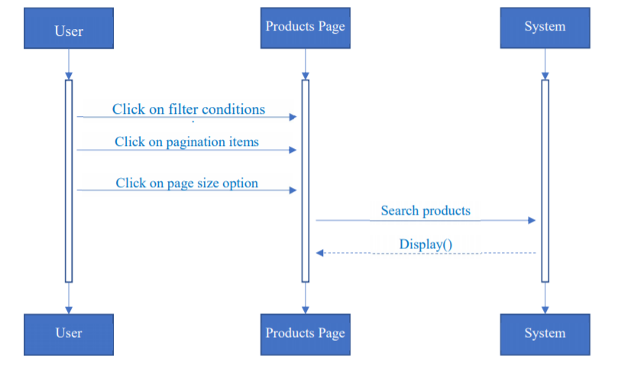

1. **View product details**

|  |  |  |
| --- | --- | --- |
| **Author** |  | |
| **Use Case Name** | View product details | |
| **Actors** | Guests and Members | |
| **Description** | Allows customers view all products which are in the same categories, brands. Products will be displayed with the pagination. | |
| **Requirements** | Links of Brands, Categories must be clicked, or range of prices must be chosen | |
|  | **Actor Actions** | **System Responses** |
| **Basic flow** | 1. Clicks on links of Brands, Categories | 2. Receive parameters passing with the links and search products which have Brands or Categories with the parameters.  3. Display the list in the products page. |

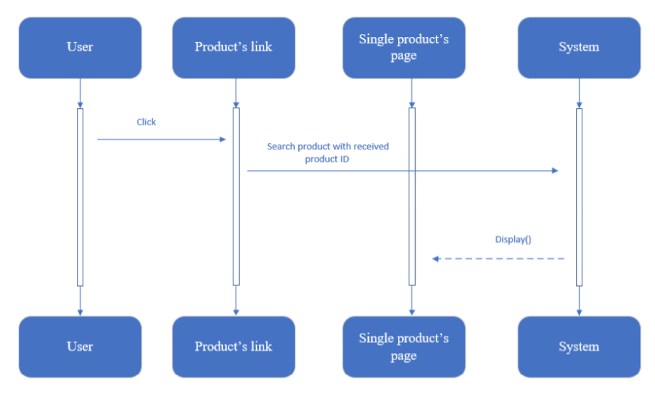

1. **Compare**

**d.1. Add:**

|  |  |  |
| --- | --- | --- |
| **Author** |  | |
| **Use Case Name** | Compare - Add | |
| **Actors** | Guests and Members | |
| **Description** | When a customer clicks on “Compare” link in singleProduct page, compare page will appear to display all compared products include added products. | |
|  | **Actor Actions** | **System Responses** |
| **Basic flow** | 1. Clicks on “Compare” link in singleProduct page. | 2. Check the number of compared products:  + if it equals 5, system disable the compare link and display a text “Reach the limit of 5 compared products”.  + else, system add the product to compared products and display compare page. |

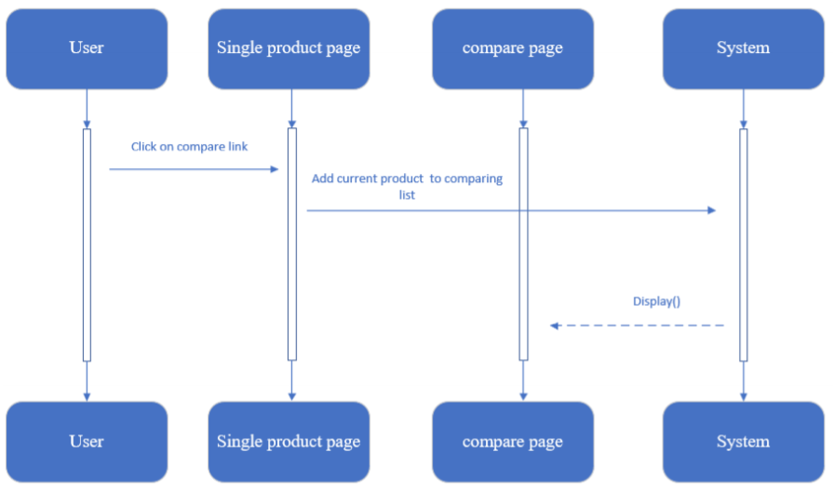

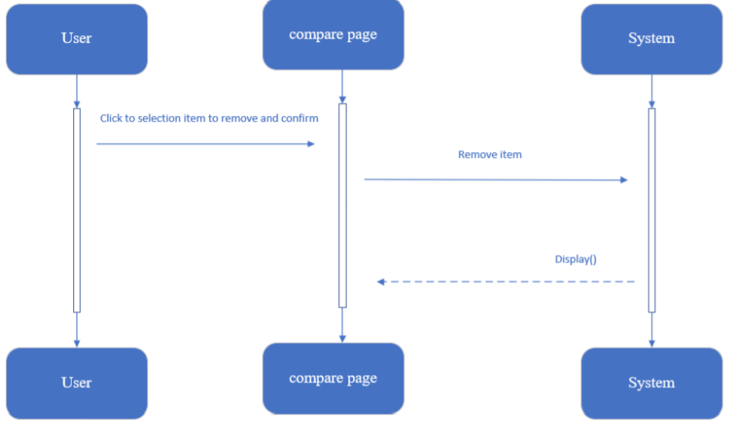**d.2. Remove:**

|  |  |  |
| --- | --- | --- |
| **Author** |  | |
| **Use Case Name** | Compare - Remove | |
| **Actors** | Guests and Members | |
| **Description** | When customer clicks on remove links and choose “Yes” to confirm, the selected product will be remove from the compared list. | |
|  | **Actor Actions** | **System Responses** |
| **Basic flow** | 1. Clicks on remove link of compared product in the compare page. 3. Clicks on “Yes” to confirm | 2. Display 2 buttons: “Yes” and “No” for customer confirm the removing. 4. Remove selected product from the compared list and display compare page with updated list. |
| **Alternative flow** | 5. Clicks on “No”. | 6. The 2 buttons disappear. |

1. **Cart**

**e.1. Add:**

|  |  |  |
| --- | --- | --- |
| **Author** |  | |
| **Use Case Name** | Cart – Add | |
| **Actors** | Guests and Members | |
| **Description** | When customers select the quantity and clicks on “Add to Cart” in singleProduct page, the current product will be added/updated into list of cart items, and cart page will be displayed with all cart items | |
|  | **Actor Actions** | **System Responses** |
| **Basic flow** | 1. Selects the quantity and clicks on “Add to Cart”. | 2. Check the added product:  + If existed in cart, system will add the quantity to the existed item’s quantity.  + Else, system will add the product with the selected quantity into the list of cart items.  3. Display the cart page with all updated cart items. |

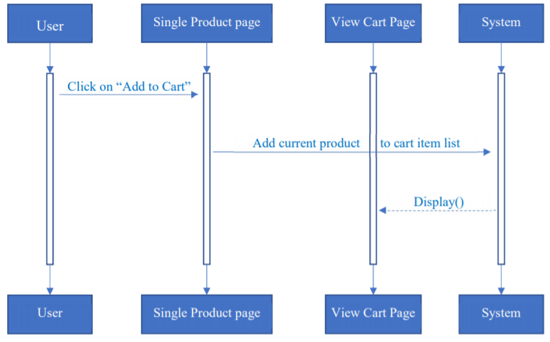

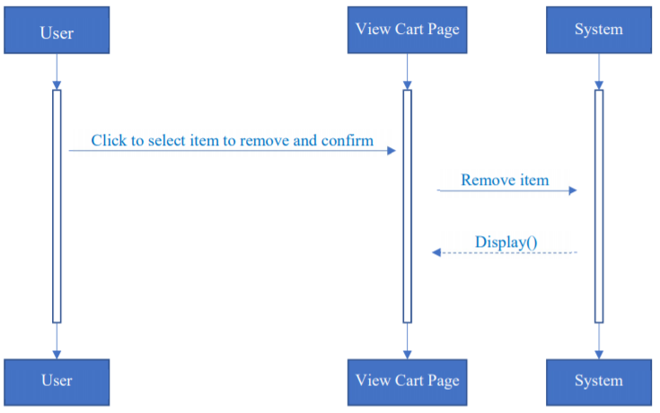**e.2. Remove**

|  |  |  |
| --- | --- | --- |
| **Author** |  | |
| **Use Case Name** | Cart – Remove | |
| **Actors** | Guests and Members | |
| **Description** | When customers clicks on remove links and choose “Yes” to confirm, the selected product will be remove from the list of cart items. | |
|  | **Actor Actions** | **System Responses** |
| **Basic flow** | 1. Clicks on remove link of cart items in the cart page.  3. Clicks on “Yes” to confirm. | 2. Display 2 buttons: “Yes” and “No” for customer confirm the removing.  4. Remove selected product from the list of cart items and display cart page with updated list. |
| **Alternative flow** | 5. Clicks on “No”. | 6. The 2 buttons disappear. |

**e.3. Update quantity:**

|  |  |  |
| --- | --- | --- |
| **Author** |  | |
| **Use Case Name** | Cart – Update quantity | |
| **Actors** | Guests and Members | |
| **Description** | When customers input quantity field of cart item, system will update the quantity, subtotal, total and display cart page with new information | |
| **Requirements** | Quantity must be greater than 0. | |
|  | **Actor Actions** | **System Responses** |
| **Basic flow** | 1. Updates new number in the quantity field. | 1. Check the new quantity [Exception 1] 2. Update new quantity, subtotal and total of cart items. 3. Display cart page with new information. |
| **Exception** | [Exception 1]   1. Actor input a number less than 0. 2. Actor input a string not in number format | * Display error message “Quantity must be greater than 0”. * Display error message “Quantity is not in number format”. |

